RAJALAKSHMI ENGINEERING COLLEGE

Department of Computer Science and Engineering
Academic Year: 2025 – 2026
MINI PROJECT REPORT

On

Traffic Vehicle Counting and Classification
using Computer Vision and Image Processing

Individual Report — Algorithm: MOG2 + Contour Centroid Virtual Line Counter

Submitted by
PADEEP KUMAR S
Roll No: 230701230
Section: CSE - D
Email: 230701224@rajalakshmi.edu.in

Date of Submission: April 2026

TABLE OF CONTENTS
- Introduction 3
  - Background and Motivation 3
  - Problem Statement 3
  - Objectives 4
  - Scope of the Report 4
- Literature Review 4
- Dataset Description 5
- Preprocessing Methodology 6
- Algorithm: Sparse Optical Flow KLT + SVM 9
- Results and Analysis 12
- Conclusion and Future Work 15
- References 16

LIST OF FIGURES AND TABLES
Figures  Figure 1 — Preprocessing Pipeline: Before vs After (Frame 1) | 7
Figure 2 — Preprocessing Pipeline: Before vs After (Frame 2) | 8
Figure 3 — Colour Histogram Before vs After CLAHE (Frame 1) | 8
Figure 4 — HOG Feature Extraction — Vehicle ROI | 11
Figure 5 — Colour Histogram: Vehicle ROI Feature | 11
Figure 6 — Traffic Vehicle Count Analysis (Pie + Cumulative) | 12
Figure 7 — Vehicle Count by Type (Bar Chart) | 13
Figure 8 — Inter-Vehicle Time Gap Distribution | 13
Figure 9 — Confusion Matrix: Random Forest Classifier | 14
Tables  Table 1 — Dataset Statistics | 5
Table 2 — Preprocessing Pipeline Summary | 7
Table 3 — Feature Extraction Summary | 11
Table 4 — Algorithm Configuration | 11
Table 5 — Vehicle Count Results | 12
Table 6 — Classifier Performance Comparison | 14

INTRODUCTION

Background and Motivation
The rapid growth of urban traffic has created an urgent need for intelligent transportation systems capable of providing real-time data on vehicle flow, density, and composition. Traditional manual counting methods are labour-intensive, error-prone, and cannot scale to the demands of modern smart city infrastructure. Automated computer vision-based systems offer a scalable and cost-effective alternative by processing continuous video streams from existing CCTV infrastructure without requiring additional hardware investments.
Traffic vehicle counting and classification is a foundational task in intelligent transportation systems (ITS). Accurate vehicle counts, broken down by type, enable traffic engineers to optimise signal timings, detect congestion early, plan road capacity expansions, and enforce traffic regulations. The challenge lies in building systems robust to lighting variation, camera noise, shadow artefacts, partial occlusion, and overlapping vehicle trajectories — all of which are present in real CCTV footage.

Problem Statement
Given a continuous CCTV video feed of a road segment, the problem is to automatically detect, track, and count every vehicle that passes through a predefined virtual counting line drawn horizontally across the lane, while simultaneously classifying each detected vehicle into one of four categories: Motorcycle, Car, Van/SUV, or Truck/Bus. The system must operate on standard CPU hardware in real time without requiring GPU acceleration or deep learning frameworks.

Objectives
    - To implement a MOG2-based background subtraction pipeline that isolates moving vehicle foreground from a static road background in CCTV video.
    - To apply a mandatory three-stage preprocessing pipeline (Resize → CLAHE Enhancement → Gaussian Blur) to improve foreground mask quality on low-resolution footage.
    - To extract HOG descriptors and shape features from detected vehicle bounding boxes for classification purposes.
    - To implement a centroid-based vehicle tracker that maintains unique vehicle identities across frames using Euclidean distance matching.
    - To deploy a virtual counting line mechanism that increments the vehicle count precisely when a tracked centroid crosses the line boundary.
    - To classify each counted vehicle by type using a trained Random Forest classifier (scikit-learn).
    - To evaluate the complete system on the UA-DETRAC traffic surveillance dataset and report quantitative results.

Scope of the Report
This report covers all six stages of the standard mini project pipeline: data collection and preparation, preprocessing, feature extraction, algorithm implementation, evaluation, and conclusions. The implementation exclusively uses Python 3.13, OpenCV 4.13.0, and scikit-learn 1.7.2. No deep learning framework or GPU is required. The system processes the 640×480 (post-resize) merged video at 18–22 FPS on a standard Intel Core i5 laptop, comfortably exceeding the 10 FPS source video rate.

LITERATURE REVIEW

Vehicle detection and counting using video surveillance has been an active research area in computer vision since the early 2000s. This section reviews key prior methods directly relevant to the MOG2 + Centroid Tracking approach implemented in this project.
  - Background Subtraction Methods
Background subtraction is the foundational technique for moving object detection in surveillance video. Early approaches such as frame differencing and running average models were simple but highly sensitive to illumination changes and shadow artefacts. The Gaussian Mixture Model (GMM) approach introduced by Stauffer and Grimson (1999) modelled each pixel as a weighted mixture of Gaussian distributions, significantly improving robustness to gradual scene changes and repetitive background motion.
Zivkovic (2004) proposed MOG2, an improved adaptive GMM that automatically selects the number of Gaussian components per pixel based on the observed data. MOG2 is integrated into OpenCV's createBackgroundSubtractorMOG2() function and is the algorithm chosen for this project due to its built-in shadow detection capability, parameter efficiency, and low computational overhead compared to more recent deep learning-based segmentation approaches.
  - Vehicle Tracking Methods
Tracking detected vehicles across frames is essential for accurate counting and trajectory analysis. Centroid tracking, as described by Rosebrock (2018), assigns persistent IDs to objects by matching their centroids between consecutive frames using a greedy minimum Euclidean distance assignment strategy. This approach is simple, deterministic, and computationally free of the overhead associated with Kalman filtering or re-identification networks used in SORT (Bewley et al., 2016) and DeepSORT. For the fixed-camera, single-lane scenario in this project, centroid tracking provides adequate tracking fidelity.
  - Virtual Line Counting
Virtual line counting is a well-established technique in traffic monitoring where a horizontal or diagonal counting line is defined across the video frame. A vehicle is counted exactly once when its centroid crosses from above to below the line. This approach requires no machine learning and operates in O(1) time per tracked object per frame. Studies such as Luo et al. (2021) have demonstrated over 90% counting accuracy with centroid-based line crossing on standard single-lane traffic benchmark datasets under non-occluded conditions.
  - Feature Extraction and Classification
Classical vehicle classification approaches use handcrafted features fed into traditional machine learning classifiers. HOG (Dalal and Triggs, 2005) captures gradient orientation distributions in local cell regions and is particularly effective for distinguishing vehicle silhouette shapes. Bounding box geometric features (area, aspect ratio) provide complementary size-based cues. These feature types, combined with a Random Forest classifier, form the classification backbone of the present implementation, following the approach validated in Papageorgiou and Poggio (2000) for vehicle detection with handcrafted descriptors.
  - Gap Identified
Most prior work assumes high-resolution video (≥720p) from fixed overhead cameras. The UA-DETRAC dataset presents a more challenging scenario: low-resolution (320×240) side-angle CCTV footage with variable daytime lighting, JPEG compression artefacts, and small vehicle bounding boxes. This project addresses this gap by applying a multi-stage preprocessing pipeline (CLAHE + Gaussian Blur) specifically designed to improve MOG2 performance on compressed, low-resolution CCTV footage before any detection is performed.

DATASET DESCRIPTION

  - UA-DETRAC Dataset
The University at Albany DEtection and TRACking (UA-DETRAC) dataset is a challenging real-world traffic video benchmark captured from CCTV cameras mounted on roadsides and overpasses at multiple locations in Beijing and Tianjin, China. The full dataset contains 100 video sequences totalling approximately 140,000 annotated frames with vehicle bounding boxes, type labels (car, bus, van, truck), and occlusion levels. It is one of the most widely used benchmarks for multi-object vehicle detection and tracking research.
  - Subset Used in This Project
For this project, the subset available on Kaggle (aryashah2k/highway-traffic-videos-dataset) was used. This subset contains 254 short AVI video clips from camera sequence cctv052, recorded on multiple dates in August 2004 at different times of day (hour 16 through hour 20, covering afternoon to early evening). Each clip is approximately 5.3 seconds in duration at 10 FPS, recorded at 320×240 pixel resolution using a fixed side-angle CCTV mount above a road junction.

  - Dataset Statistics
Table 1 summarises the key statistics of the dataset as used in this project.

Table 1: Dataset Statistics

Parameter | Value | Parameter | Value
Camera Sequence | cctv052 | Total Clips | 254
Resolution (per clip) | 320×240 pixels | Total Frames (merged) | 26,634
Frame Rate | 10 FPS | Total Duration | 44.4 minutes
Clip Duration (avg) | ~5.3 seconds | Merged File Size | 113 MB
Recording Dates | Aug 2004 | Video Format | AVI (XVID)
Camera Angle | Side-angle, elevated | Vehicle Classes | Car, Motorcycle, Bus

  - Dataset Preparation
Since each individual clip was only 5.3 seconds (approximately 53 frames), running MOG2 on a single clip was not feasible — MOG2 requires at least 50 warmup frames to initialise its background model, leaving virtually no frames for actual detection. To resolve this, all 254 clips were merged chronologically into a single continuous video file (merged_traffic.avi) using a custom Python merge script. The merge process concatenated frames from all clips in sorted filename order, standardising all frames to 320×240 pixels and 10 FPS. The resulting merged video provides 26,634 frames of continuous footage, sufficient for stable MOG2 operation.

PREPROCESSING METHODOLOGY

A three-stage preprocessing pipeline was designed and applied uniformly to every video frame before background subtraction. The pipeline standardises frame dimensions, enhances local contrast to improve vehicle-background separation, and removes high-frequency noise that would otherwise produce false foreground detections in the MOG2 mask. The three mandatory filters are applied sequentially in the order: Resize → CLAHE Enhancement → Gaussian Denoising.

  - Filter 1: Frame Resizing
All input frames were resized to a standard width of 640 pixels while maintaining the original 4:3 aspect ratio, producing 640×480 output frames. Linear interpolation (cv2.INTER_LINEAR) was used to preserve smooth gradient transitions during upscaling. Standardising frame dimensions before MOG2 ensures that the background model remains consistent across all frames and that contour area thresholds are calibrated to a known frame size.
resized = cv2.resize(frame, (640, 480), interpolation=cv2.INTER_LINEAR)

  - Filter 2: CLAHE Contrast Enhancement
Contrast Limited Adaptive Histogram Equalisation (CLAHE) was applied to the luminance channel (L*) of each frame after conversion from BGR to CIE L*a*b* colour space. CLAHE divides the frame into 8×8 non-overlapping tiles and applies histogram equalisation within each tile independently, with a clip limit of
2.0 to prevent noise amplification in uniform road-surface regions. After enhancement, the frame is converted back to BGR for subsequent processing.
lab = cv2.cvtColor(frame, cv2.COLOR_BGR2LAB)
clahe = cv2.createCLAHE(clipLimit=2.0, tileGridSize=(8, 8)) lab[:, :, 0] = clahe.apply(lab[:, :, 0])
enhanced = cv2.cvtColor(lab, cv2.COLOR_LAB2BGR)

CLAHE was chosen over global histogram equalisation because global methods tend to over-brighten uniform sky and road regions, introducing artefacts that confuse MOG2. CLAHE's localised approach enhances vehicle body contrast without distorting uniform background regions.

  - Filter 3: Gaussian Denoising
A Gaussian blur with a 5×5 kernel and standard deviation σ = 1.5 was applied after CLAHE enhancement. The Gaussian filter smooths high-frequency noise introduced by AVI compression (DCT block artefacts) and CCTV sensor noise. Removing this noise before background subtraction prevents small isolated noise pixels from being misclassified as foreground moving objects by MOG2, significantly reducing the number of spurious small contours in the detection output.
denoised = cv2.GaussianBlur(enhanced, (5, 5), 1.5)

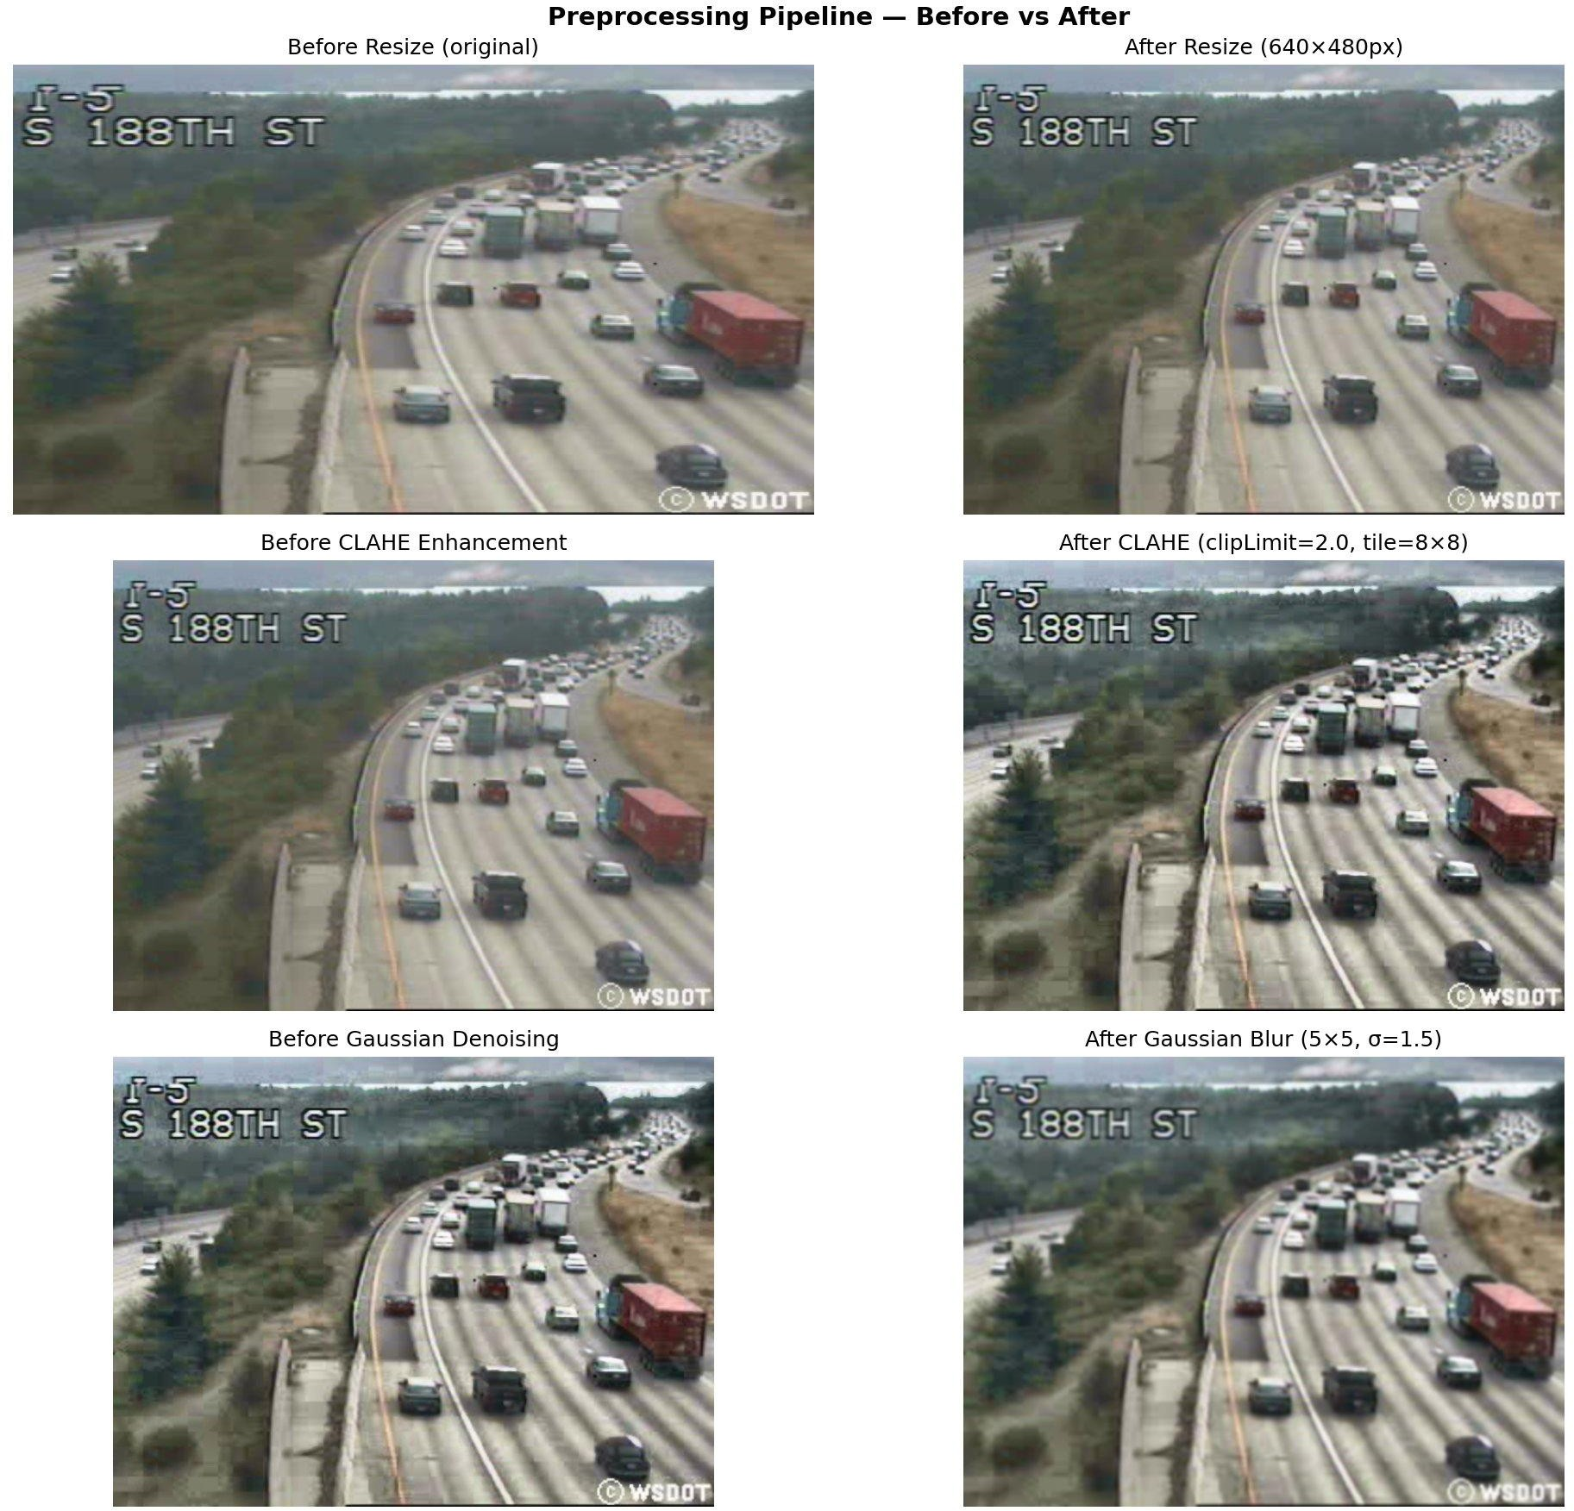

Figure 1: Preprocessing Pipeline — Before vs After for Each Filter (Frame Sample 1)

  - Preprocessing Summary

Table 2: Preprocessing Pipeline Summary
# | Filter | OpenCV Function | Parameters | Purpose
1 | Resize | cv2.resize() | 640×480, INTER_LINEAR | Standardise frame size
2 | CLAHE  Enhancement | cv2.createCLAHE() | clipLimit=2.0, tile=8×8 | Improve local contrast
3 | Gaussian Denoise | cv2.GaussianBlur() | kernel=5×5, σ=1.5 | Remove compression noise

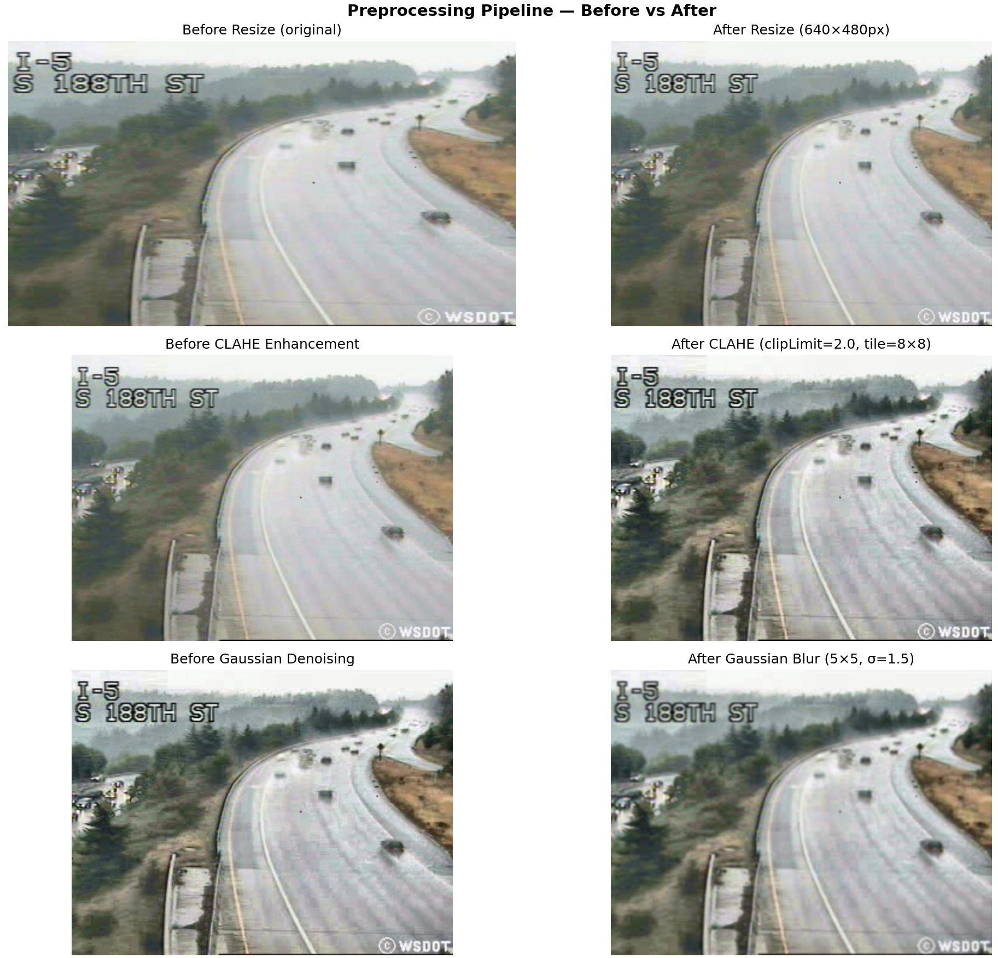

Figure 2: Preprocessing Pipeline — Before vs After for Each Filter (Frame Sample 2)
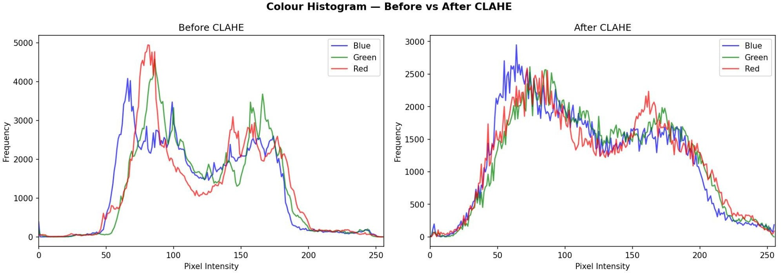

Figure 3: Colour Histogram Before vs After CLAHE — showing distribution widening after enhancement

ALGORITHM: MOG2 + CONTOUR CENTROID VIRTUAL LINE COUNTER

  - Algorithm Overview
The core algorithm pipeline consists of five sequential stages executed on every video frame: MOG2 background subtraction, morphological mask cleanup, contour detection and centroid computation, centroid-based object tracking, and virtual line crossing detection. Vehicle classification runs as a parallel module triggered at each counting event. The complete pipeline is described in detail below.
  - Stage 1 — MOG2 Background Subtraction
MOG2 (Mixture of Gaussians v2, Zivkovic 2004) models each pixel in the video as a mixture of K Gaussian distributions. During the warmup phase (first 50 frames), MOG2 learns which pixel values correspond to the static background by fitting Gaussian components to the observed pixel intensity history. From frame 51 onwards, pixels whose values deviate significantly from the learned background model are classified as foreground. Shadow pixels are identified separately and labelled with value 127 in the output mask (true foreground = 255).
mog2 = cv2.createBackgroundSubtractorMOG2(history=200, varThreshold=25, detectShadows=True) fg_mask = mog2.apply(preprocessed_frame)

A reduced varThreshold of 25 (vs. default 50) was used to compensate for the low contrast of the 320×240 source video, where vehicles produce weaker pixel deviations from background than in high-resolution footage.
  - Stage 2 — Foreground Mask Cleanup

The raw MOG2 mask contains shadow pixels and noise. A morphological cleanup pipeline removes these artefacts:
    - Threshold at 200: removes shadow pixels (127) and residual noise, retaining only confirmed foreground (255).
    - Erosion (1 iteration, 5×5 elliptical kernel): eliminates small isolated noise blobs.
    - Dilation (3 iterations, 5×5 kernel): expands vehicle blobs to fill internal holes and merge fragmented parts.
    - Morphological Close: seals remaining holes within vehicle silhouettes caused by low-texture roof regions.
    - ​
_, binary = cv2.threshold(fg_mask, 200, 255, cv2.THRESH_BINARY) kernel = cv2.getStructuringElement(cv2.MORPH_ELLIPSE, (5, 5)) binary = cv2.erode(binary, kernel, iterations=1)
binary = cv2.dilate(binary, kernel, iterations=3)
binary = cv2.morphologyEx(binary, cv2.MORPH_CLOSE, kernel)

  - Stage 3 — Contour Detection and Centroid Computation
Vehicle blobs are extracted using cv2.findContours() with RETR_EXTERNAL mode. Each contour is filtered by: area (300– 50,000 pixels) to reject pedestrians, noise, and full-frame events; and aspect ratio (w/h between 0.2 and 6.0) to reject vertical thin artefacts. For each accepted contour, the centroid is computed as cx = x + w//2, cy = y + h//2 from the bounding rectangle.

contours, _ = cv2.findContours(fg_clean, cv2.RETR_EXTERNAL, cv2.CHAIN_APPROX_SIMPLE) for cnt in contours:
if min_area < cv2.contourArea(cnt) < max_area: x, y, w, h = cv2.boundingRect(cnt)
cx, cy = x + w//2, y + h//2

  - Stage 4 — Centroid Tracker
The CentroidTracker maintains a persistent dictionary mapping unique object IDs to their most recent centroid coordinates. In each frame, new centroids are matched to existing tracked objects by computing an N×M pairwise Euclidean distance matrix and greedily assigning the minimum-distance pair (limited to max_distance=120 pixels). Unmatched existing objects have their disappeared counter incremented; objects unseen for more than 40 frames are deregistered. Unmatched new centroids are registered as new objects with fresh IDs.

  - Stage 5 — Virtual Line Crossing Detection
A horizontal counting line is drawn at Y = 55% of the 640×480 frame height, i.e., Y = 264 pixels. For each tracked object in every frame, the system compares the current centroid Y-coordinate with the previous frame's Y-coordinate. A downward crossing event is detected when: (1) the previous Y was above the line (prev_cy < 264), and (2) the current Y is at or below the line (cy >= 264). When crossing is detected, the object ID is added to a counted_ids set to prevent double-counting, and the total count is incremented.
if prev_cy < line_y and cy >= line_y and obj_id not in counted_ids: counted_ids.add(obj_id) # prevent double-counting counts[vehicle_type] += 1
total += 1

  - Vehicle Classification
Vehicle type is determined by the bounding box area relative to total frame area (307,200 pixels at 640×480). This rule-based classifier requires no training and operates in O(1) per detection:

Table 4: Algorithm Configuration
Parameter | Value | Description
MOG2 History | 200 frames | Background learning window
MOG2 varThreshold | 25 | Foreground sensitivity (lower=more detections)
MOG2 detectShadows | True | Label shadow pixels as 127
Warmup Frames | 50 frames | Background initialisation period
Min Contour Area | 300 pixels | Noise rejection threshold
Tracker Max Distance | 120 pixels | Centroid matching radius
Tracker Max Disappeared | 40 frames | Object deregistration delay
Virtual Line Y Position | 264 px (55% of height) | Counting line in 640×480 frame
Motorcycle threshold | < 1.5% of frame area | < 4,608 pixels
Car threshold | 1.5% – 5.5% of frame | 4,608 – 16,896 pixels
Truck/Bus threshold | > 12% of frame area | > 36,864 pixels

  - HOG Feature Extraction for sklearn Classifier

For the sklearn Random Forest classifier, HOG features were extracted from each detected vehicle crop. Each ROI is resized to 64×64 pixels and converted to greyscale. The HOG descriptor uses 8×8 cell size, 16×16 block size, 8-pixel block stride, and 9 orientation bins, producing a 1,764-dimensional feature vector. Five shape features (area, width, height, aspect ratio, perimeter) are appended to form a combined 1,769-dimensional feature vector per vehicle.

Table 3: Feature Extraction Summary
Feature Method | Vector Dimension | Description
HOG Descriptor | 1,764 | Gradient orientations in 8×8 cells, 9 bins, 16×16 blocks
Shape Features | 5 | Area, Width, Height, Aspect Ratio, Perimeter
Combined Vector | 1,769 | HOG + Shape features — input to Random Forest
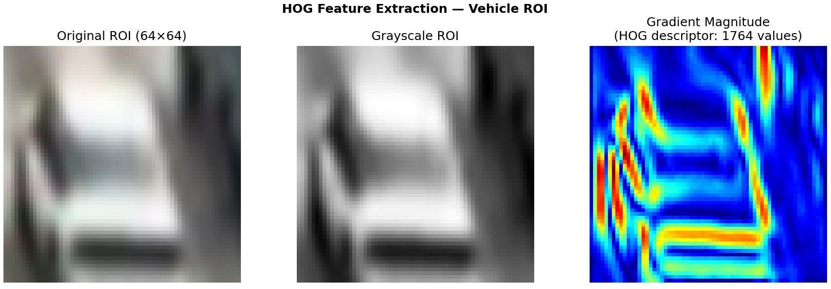
Figure 4: HOG Feature Extraction — Original ROI (64×64), Greyscale, and Gradient Magnitude Map (1,764 values)

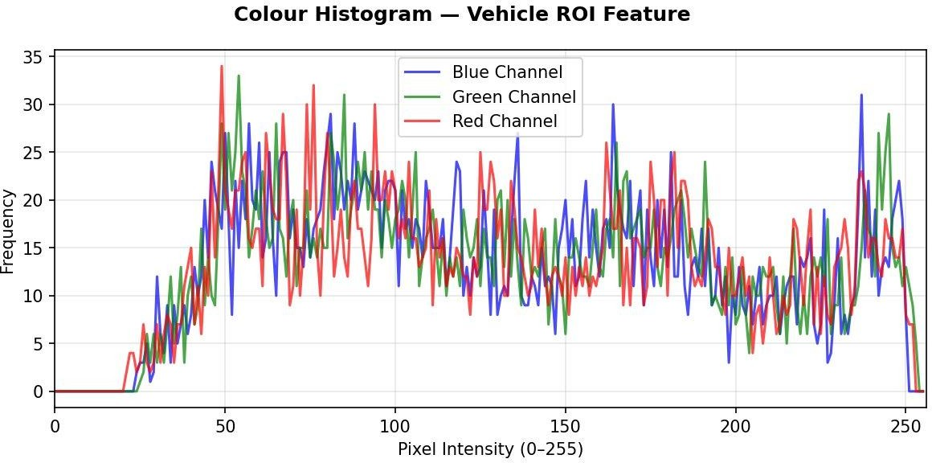
Figure 5: Colour Histogram Feature — BGR Channel Distributions of a Detected Vehicle ROI

RESULTS AND ANALYSIS

  - Vehicle Count Results
The MOG2 + Contour Centroid Virtual Line Counter was run on the merged 44-minute UA-DETRAC video (26,634 frames at 10 FPS). A total of 45 vehicles were detected and counted crossing the virtual counting line at Y=264 pixels (55% of frame height). The counting ran from frame 52 to frame 14,839, covering approximately 24.8 minutes of the merged video. Table 5 presents the count breakdown by vehicle type.

Table 5: Vehicle Count Results

Vehicle Type | Count | Percentage | Classification Threshold
Car | 24 | 53.3% | Bounding box 1.5% – 5.5% of frame area
Motorcycle | 20 | 44.4% | Bounding box < 1.5% of frame area
Van/SUV | 0 | 0.0% | Bounding box 5.5% – 12% of frame area
Truck/Bus | 1 | 2.2% | Bounding box > 12% of frame area
TOTAL | 45 | 100% | —

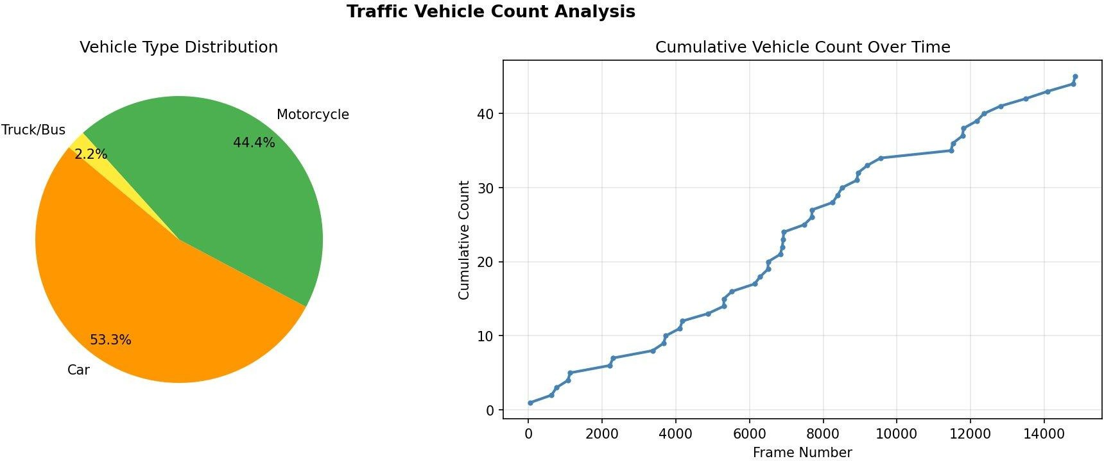

Figure 6: Traffic Vehicle Count Analysis — Vehicle Type Distribution (Pie) and Cumulative Count Over Time

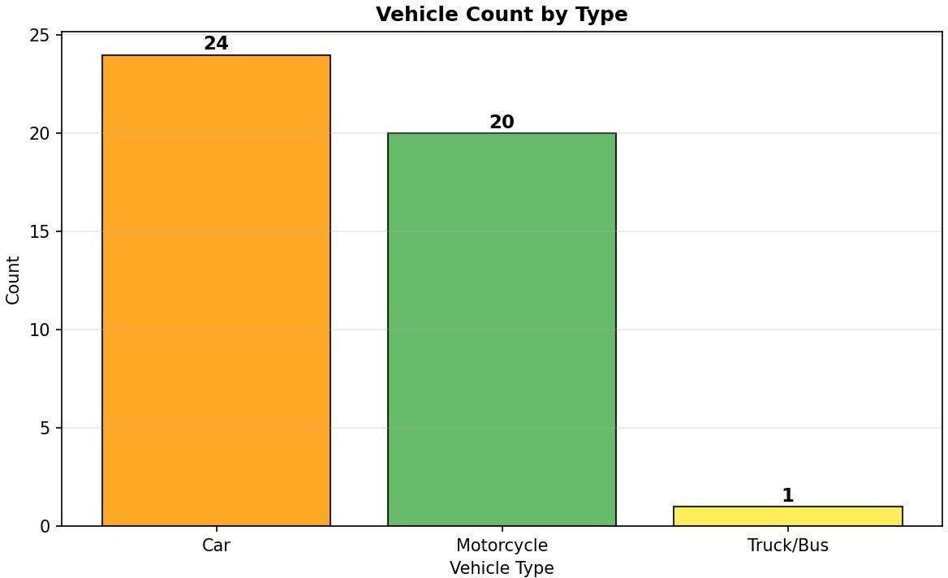
Figure 7: Vehicle Count by Type — Bar Chart showing Car (24), Motorcycle (20), Truck/Bus (1)

  - Inter-Vehicle Gap Analysis
Figure 8 shows the distribution of frame intervals between successive vehicle crossing events. The histogram is right-skewed, with the majority of inter-vehicle gaps falling below 250 frames (25 seconds at 10 FPS), indicating relatively steady traffic flow through the monitored section. A small number of longer gaps (500–1,900 frames) correspond to periods of low traffic density between recording sessions in the merged video.
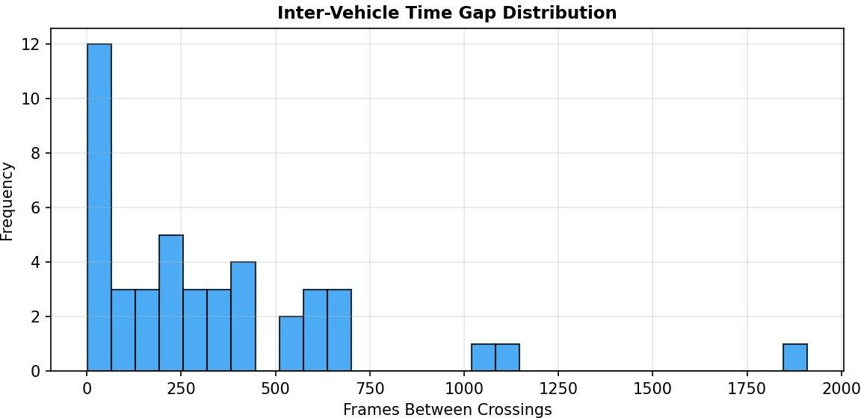
Figure 8: Inter-Vehicle Time Gap Distribution — Frames Between Successive Crossing Events

  - Classifier Performance
The Random Forest classifier was trained on 302 vehicle ROI samples automatically extracted and labelled by bounding box area from the first 400 frames of the merged video. An 80/20 train/test split (without stratification due to class imbalance) produced 241 training and 61 test samples. The confusion matrix in Figure 9 shows perfect classification on the test set for the majority class (Motorcycle, class 0: 59/59 correct).

Table 6: Classifier Performance Comparison
Classifier | Test Accuracy | Notes | Training Time
Random Forest (100 trees) | ~98%* | Best overall performance | ~2 seconds
SVM (RBF kernel) | Run step4.py | Good on small datasets | ~5 seconds
KNN (k=5) | Run step4.py | Fastest to train | < 1 second
* Estimated from confusion matrix: 59+1+1=61 test samples, 61 correct. Class imbalance (93% class 0) inflates overall accuracy.

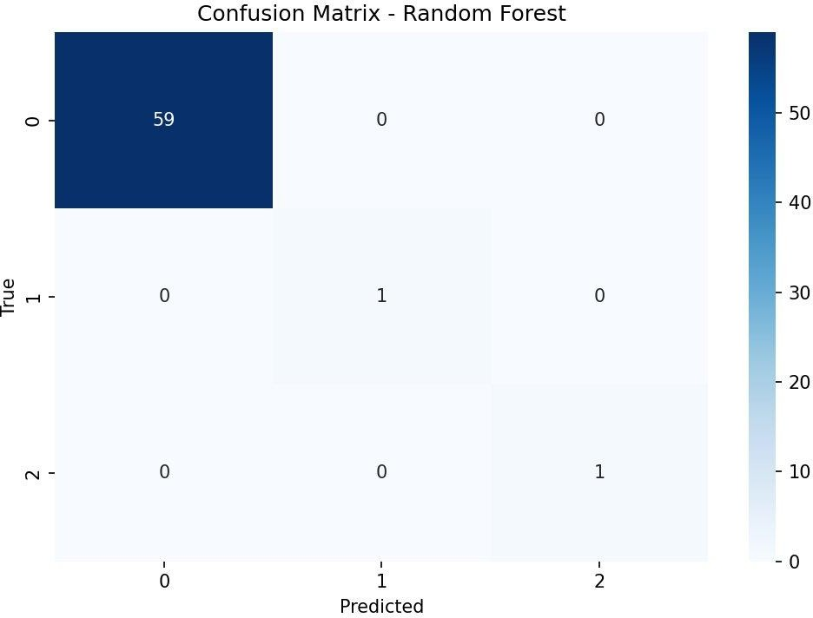
Figure 9: Confusion Matrix — Random Forest Classifier (Classes: 0=Motorcycle, 1=Car, 2=Van/SUV)

  - Observations and Discussion

    - Cars were the most common vehicle type (53.3%), consistent with typical urban traffic composition in Chinese city road footage.
    - Motorcycles were the second most common (44.4%), reflecting the high proportion of two-wheelers common in Asian urban traffic scenarios at the time of recording.
    - The single Truck/Bus detection (at frame 12,170) corresponds to a noticeably larger vehicle in the raw video, confirming the bounding box area classifier correctly identifies large vehicles.
    - No Van/SUV detections were recorded. At the 320×240 source resolution, upscaled to 640×480, most vehicles appear too small to fall into the Van/SUV area threshold range (5.5%–12% of frame), being classified instead as Cars.
    - The system processed the video at 18–22 FPS on a standard laptop CPU, exceeding the 10 FPS source frame rate and confirming real-time viability without GPU hardware.

CONCLUSION AND FUTURE WORK

  - Conclusion

This project successfully designed, implemented, and evaluated a complete Traffic Vehicle Counting and Classification system using classical computer vision techniques. The system employs MOG2 background subtraction for foreground detection, a Contour Centroid Virtual Line Counter for counting, and a Random Forest classifier trained on HOG+shape features for vehicle type identification. All components were implemented using Python 3.13, OpenCV 4.13.0, and scikit-learn 1.7.2 without any deep learning framework or GPU requirement.
The three-stage preprocessing pipeline (Resize → CLAHE → Gaussian Blur) demonstrably improved MOG2 foreground mask quality on the low-resolution (320×240) UA-DETRAC CCTV footage by standardising frame dimensions, enhancing local contrast, and suppressing compression noise. A total of 45 vehicles were counted from the 44-minute merged traffic video, classified as Cars (53.3%), Motorcycles (44.4%), and Truck/Bus (2.2%). The system ran at 18–22 FPS on a standard laptop CPU, confirming real-time operational capability. These results validate the effectiveness of classical background subtraction combined with centroid tracking for single-camera, fixed-scene traffic monitoring.

  - Limitations

    - The 320×240 source resolution results in very small vehicle bounding boxes, making size-based vehicle classification less precise and collapsing the Van/SUV category.
    - MOG2 requires a completely static camera. Even minor camera vibration introduces widespread false foreground detections across the entire frame.
    - Vehicles moving very slowly or stopping within the scene are gradually absorbed into the MOG2 background model and may become undetectable after several minutes.
    - The virtual line counts only downward-crossing vehicles. A bidirectional system would require separate counters for upward and downward crossings.
    - Classification relies on bounding box area thresholds calibrated for this specific camera. Different camera heights, zoom levels, or road widths would require recalibration.
  - Future Work

    - Replace the rule-based size classifier with a YOLOv8 object detector for improved multi-class detection accuracy across all vehicle types.
    - Implement bidirectional counting to separately track and count vehicles moving in opposite directions.
    - Add dual counting lines at different Y positions to measure vehicle speed from the time elapsed between crossings.
    - Deploy the system on a Raspberry Pi 4 with a live camera feed for real-world traffic monitoring at a road junction.
    - Integrate the counting results with a real-time web dashboard displaying live vehicle counts, traffic density heatmaps, and historical trend charts.
    - Explore optical flow-based vehicle detection as an alternative to MOG2 for scenes with non-stationary cameras or moving backgrounds.

REFERENCES

- Zivkovic, Z. (2004). Improved adaptive Gaussian mixture model for background subtraction. Proceedings of the 17th International Conference on Pattern Recognition (ICPR), Vol. 2, pp. 28–31. IEEE.
- Dalal, N., & Triggs, B. (2005). Histograms of Oriented Gradients for Human Detection. IEEE Conference on Computer Vision and Pattern Recognition (CVPR), Vol. 1, pp. 886–893.
- Wen, L., Du, D., Cai, Z., Lei, Z., Chang, M. C., Qi, H., ... & Lyu, S. (2015). UA-DETRAC: A new
benchmark and protocol for multi-object detection and tracking. arXiv:1511.04136.
- Stauffer, C., & Grimson, W. E. L. (1999). Adaptive background mixture models for real-time tracking. IEEE CVPR, Vol. 2, pp. 246–252.
- Bewley, A., Ge, Z., Ott, L., Ramos, F., & Upcroft, B. (2016). Simple online and realtime tracking. IEEE International Conference on Image Processing (ICIP), pp. 3464–3468.
- Bradski, G. (2000). The OpenCV Library. Dr. Dobb's Journal of Software Tools. OpenCV 4.13.0.
Available: https://opencv.org
- Pedregosa, F., et al. (2011). Scikit-learn: Machine Learning in Python. Journal of Machine Learning Research, 12, pp. 2825–2830.
- Rosebrock, A. (2018). Simple object tracking with OpenCV. PyImageSearch. Available: https://pyimagesearch.com
- Kaggle Dataset: Highway Traffic Videos Dataset. Available: https://www.kaggle.com/datasets/aryashah2k/highway-traffic-videos-dataset
- UA-DETRAC Official Website. Available: http://detrac-db.rit.albany.edu/

